Advanced Emotion Detection System: Integrating Image processing and Multiple Machine Learning Models

Karthik D

Electronics and Instrumentation*)*

Bms College of Engineering

Bangalore, Karnataka

kd1742002@gmail.comVishant Singh

Electronics and Instrumentation*)*

Bms College of Engineering

Kanpur uttarpradesh

vishantt.singh@gmail.com

C.Gururaj Senior Member IEEE

Dept. of Electronics and Telecommunication

BMS College of Engineering   
[gururaj.tce@bmsce.ac.in](mailto:gururaj.tce@bmsce.ac.in)

**Abstract:**

This project conducts extensive research into search theory and aims to improve the performance of existing systems. This report details these technologies by combining image processing techniques and machine learning models, including Convolutional Neural Networks (CNN), Support Vector Machines (SVM), Random Forests, K-Nearest Neighbors (KNN), and Logistic Regression. and analysis of the curiosity system. This great need is to improve the accuracy, robustness, and flexibility of facial recognition, thus expanding its applications in human-computer interaction and migration.

**Introduction:**

This project begins the exciting journey of understanding and analyzing behavior. Our goal is to improve existing systems by combining intelligent imaging techniques with computer systems that can learn from examples. These programs include neural network (CNN), support vector machine (SVM), random forest, K-nearest neighbor (KNN), and logistic regression. In this article, we will show you the steps to create the ultimate emotional experience. Our goal is to make recognizing faces like happiness and sadness better and more accurate. We believe this will positively impact how people interact with computers and even in other areas outside of computers.

**Literature Review:**

• Emotion-based emotional recognition using neural networks:

Emotional recognition is widely used in social life and business world. Various classifiers are used, especially the convolutional neural network (CNN). Building a CNN model from scratch can be difficult; therefore, training changes from the pre-training model are often preferred to improve performance and runtime. This article introduces a new data generation using visual search engine and classifier using CNN with transformation support. Use data prioritization techniques to improve classification efficiency. A detailed description of the experimental studies is presented.

Author: Tayyip Özcan

Publication date: August 22, 2021

• Current Trends in Emotion Perception: Ensemble Effectiveness

This study introduces the use of the Video-Based "Emotion Wheel Model". facial recognition method. Inspired by the evolution of emotions in psychology, we use this model as a bias to improve the accuracy of facial recognition. The performance was evaluated on CK+, MMI and AFEW data, and the recognition rate of this method reached 98.78%, 81.95% and 55.31%, respectively. These rates are 3.67%, 6.34% and 4.9% higher than baseline. In particular, the proposed method outperforms the methods on MMI and AFEW datasets.

Author: Noriko Nagata

Published date: October 18, 2022

• Instant facial emotion recognition system with improved pre-processing and feature extraction

The knowledge of human emotions in the individual and is very important in human life. human-computer relationship. Emotions expressed through words, gestures, body movements, and facial expressions are important for understanding communication. Facial expressions play an important role in determining language. Although there are many Facial Emotion Recognition (FER), their real-life performance is often limited. Although the near-perfect claim is in favor, the diversity of expressions and faces makes it difficult to create the opposite. This article is designed to develop an improved FER and perform performance evaluation using data such as JAFFE and FER2013. By integrating advanced techniques such as facial features and Histogram of Oriented Gradins (HOG) into a convolutional neural network (CNN), the proposed system achieves high accuracy compared to existing models.

Author: Abhishek MC

Published Date: October 6, 2020

**Aims and Objectives:**

• Problem Description:

Due to the subtle and powerful nature of the human mind, using images to learn and study well with the problem of thinking Machine Learning (ML) technology to confront. Current systems are often unreliable in real life and have difficulty capturing different expressions and faces.

• Goals:

1) Develop strong emotional recognition that can accurately identify faces in real time.

• Goals:

1) Develop strong emotional recognition that can accurately identify faces in real time. < br > 2) Use image learning and machine learning to solve the limitations of current systems.

3) Consider changes in expression and facial expression to improve performance in different situations.

4) Use datasets and predefined methods to increase the efficiency and accuracy of the system.

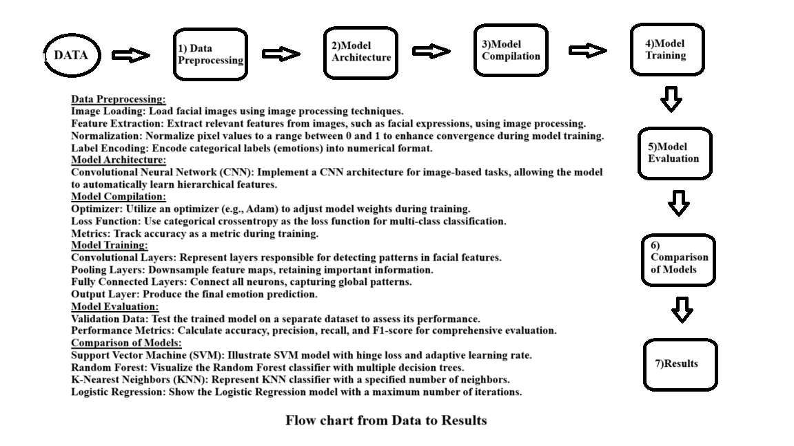5) Develop an open and reliable model to support human-computer interaction and other applications.5) Establish a definitive and reliable emotion recognition model to advance human-computer interaction and other applications.

**Design Methodology:**

1. Data Preparation:

Index Setup:

Creating an index is the first important step in setting up training and testing data. These directories, called "TRAIN_DIR" and "TEST_DIR", are used to allocate images for training and testing models. The goal is to provide a systematic and effective structure that creates a clear workflow throughout the machine learning project. This planning phase is used by the programming code.

Creating a Data Frame:

Creating a data frame represented as "training" and "testing" is crucial for good data management. This model provides a unified framework for processing training and testing data by organizing image paths and their corresponding labels. Using data frames increases accessibility and simplifies the processing of continuous data and model training steps.

2. Image feature extraction:

Function description:

To facilitate image processing for machine learning, a function called Feature Extraction has been formulated. This function takes a list of image paths as input. It uses grayscale conversion as a pre-processing step to systematically process each image in the inventory. The resulting images are then compiled into arrays. The array is then rescaled to meet the requirements of the machine learning model.

Feature Extraction:

In the context of machine learning generated images, the feature extraction process has a versatile approach. A function called “Extract Features” plays an important role in this process.

Image path iteration: The feature extraction function systematically traverses the image path. This iterative process ensures that each image in the file is passed to the next extraction step.

Properly processed grayscale conversion: One of the first steps in feature extraction is to convert each image to grayscale. This step ensures a consistent run, facilitating subsequent analysis and management.

Structured sequence formation: The completed image is then assembled into a structured sequence. This design model forms the basis of training a good model by supporting the organization, storage and retrieval of information.

Reshape model compatibility:

Reshape the array to meet the requirements of machine learning models. This step is important to ensure that the results are presented in a format compatible with the chosen neural network architecture.

Pixel value normalization for improved integration: As a final preparation step, pixel values ​​in the array are normalized. This normalization improves model convergence during training and facilitates better learning.

3. Tag Coding and Encoding:

Tag Coding: In the first stage, the desired tag is converted into string format using the encoder. This coding method makes integration with machine learning models easier by assigning a unique code to each different emotional symbol. The result of numerical representation improves the interpretation of ideas within a computational framework.

Single-Run coding: After tag coding, use the two-split function to perform Single-Run coding. This process transforms emotional symbols into binary matrices. Each digit is converted into a binary vector, creating a categorical representation. This binary matrix is ​​particularly useful for classifying tasks to enable the model to recognize and deploy multiple hypotheses during training and testing. Integration of one-shot coding increases the model's effectiveness in capturing relationships between emotions.

4. Neural network model:

Model description: Neural network architecture consists of convolutional processes and all layers. This hybrid design allows the model to capture hierarchical features in the input image. Convolutional layers focus on local patterns, while all other layers combine global information to get the best results.

Model compilation: In preparation for training, the model is compiled using an optimizer and a categorical cross-entropy loss function. Optimizers help adjust the weights during training, improving the model's ability to converge to the optimal solution. Categorical cross-entropy is a suitable choice for multi-class classification, measuring the difference between the predicted distribution and the actual result.

Training model: The training process involves exposing the model to training data, allowing it to learn and adjust its constraints. To ensure consistency, the model's performance was validated on separate datasets. During training, the model adjusts the weight to minimize loss, thus improving the ability to accurately identify the face.

Save the training model: After the training is completed, the model is saved in two formats: JSON and H5. JSON format stores structural information, while H5 format stores weights. This dual storage makes it easy to recall and reuse training models so they can be integrated into future applications or analyzes without the need for redoing.

5. Support Vector Machine (SVM):

Model Description: A Support Vector Machine (SVM) is initialized using the SGD classifier, which is a linear classifier using stochastic gradient descent. Hinge loss is an important feature of SVM and is used to measure classification error. Flexibility of learning provides flexibility and improves integration during learning. Constant random seeding ensures repeatability of sample results.

Data preparation: Image vectors are modified and modeled to meet the requirements of the SVM. Reshaping ensures that the data type fits the SVM model, while normalization reduces the impact of different feature sizes by transforming the data into a single measurement. This preliminary step improves the performance of SVM by promoting consistent results.

Model training: SVM models are trained using stochastic gradient descent on the training data set. During training, the model learns parameters, including hyperplanes, that allow separation of different groups of thoughts. The nature of stochastic gradient descent will help in appropriately tuning the decision boundary model for the distribution.

Evaluate the model: Evaluate the SVM model on test data to evaluate its accuracy after training. Accuracy is a metric that measures a model's ability to describe different behaviors. The predicted text is compared to the actual text in the test data, giving a score for the model's performance and generality to unseen data.

6. Random Forest:

Model description: Random Forest model is a multifunctional integrated learning algorithm that works by creating a large number of decision trees during training. Each decision tree is created independently and the final prediction is determined by summing the predictions from each tree. The model is instantiated using a random forest classifier in scikit-learn, with important parameters such as trees (n estimate) and a fixed random seed (random state) for reproducibility.

Data preparation: Random Forest model data is prepared and feature vectors are flattened and standardized. Flattening transforms multidimensional feature vectors into a one-dimensional format, making them compatible with a decision tree. Normalization ensures that all features are equal, which is important for the performance of the algorithm.

Training model: The training level should adapt the random forest model to the training data and process. In this process, each decision tree in the classroom learns from different educational materials, capturing different patterns and relationships in a particular domain. A fitting method is used to train the model.

Model evaluation: After training, evaluate the accuracy of the random forest model on test data. This model creates a prediction (rf pred) of the test data and uses the test scores to calculate the correct score. This score represents the proportion of cases classified and can provide insight into the overall performance of the model.

7. K-Nearest Neighbor (KNN):

Model Description: K-Nearest Neighbor (KNN) is a non-parametric, instance-based learning algorithm for classification and regression. In the given code snippet:

Create KNN classifier: Create the 5-neighbour KNN classifier using the K Neighbors classifier in scikit-learn. This classification makes predictions based on the most common classes of nearest neighbors.

Data preparation: To make the feature vectors consistent with the KNN model, the following steps should be performed:

• Flatten the feature vectors: Reshaping the input flattens the data by flattening the feature vectors. This step converts multivariate data into a single sequence for easy correlation with the KNN algorithm.

• Standardized profiles: Use normalization to ensure all features are equal. This technique involves subtracting the mean and dividing by the standard deviation, thus improving the performance of the algorithm.

Training models: Training a KNN model involves storing all training data in memory. The KNN algorithm does not produce clear patterns during training. Instead, it remembers training events to make predictions based on the consistency of input and stored values.

Evaluating the model:

Once the model is trained, it is evaluated on the test data:< br> • Generate predictions: Use the trained KNN model to create a prediction of the test data.

• Accuracy testing: Test the accuracy of your KNN model by comparing the predicted text to the actual text using the true score. This score represents the model's ability to accurately describe the sample.

8. Logistic Regression:

Model Description: Logistic regression is a linear model that fits binary and multiple distribution functions. Initialize a logistic regression model in the code snippet: Build a logistic regression model with up to 1000 iterations using the Logistic Regression category in Scikit-learn. The number of iterations determines how many times the algorithm adjusts the weights to optimize the model.

Data preparation: To prepare your data for logistic regression, you need to follow these steps:

• Flatten eigenvectors: Reshape the input data by flattening the eigenvectors. This step transforms multidimensional data into a linear model, making it compatible with the logistic regression algorithm.

• Standardized profiles: Use normalization to ensure all features are equal. This process involves subtracting the mean and dividing it by the standard deviation to facilitate integration during optimization.

Model training: Training of the logistic regression model should optimize the model parameters based on the training data.

• Flattened data training: Use the method to train the model on training data and models. During training, the algorithm adjusts the weights to reduce the logistic loss function, aiming to classify the examples correctly.

Evaluate the model: After training, evaluate the model on test data:

• Generate predictions: Use the learned logistic regression model to make predictions on competitive benchmark data.

• Validity test: Test the validity of the logistic regression model by comparing the predicted text to the actual text using measured scores. This score provides insight into the model's ability to accurately identify samples.

9.Comparative Analysis:

In this stage of the evaluation, the focus is on comparing the accuracy of multiple models employed for emotion detection, including the neural network, SVM, Random Forest, KNN, and Logistic Regression.

Model Accuracy Comparison: Each model's accuracy is individually assessed using specific metrics:

• Neural Network Accuracy: The accuracy of the neural network model is determined by employing the evaluate method on the testing dataset.

• SVM Accuracy: The accuracy of the SVM model is evaluated using the accuracy score metric, comparing predicted labels with actual labels.

• Random Forest Accuracy: The accuracy of the Random Forest model is determined by comparing predicted labels with true labels on the testing dataset.

• KNN Accuracy: The accuracy of the KNN model is evaluated by comparing predicted labels with actual labels on the testing dataset.

• Logistic Regression Accuracy: The accuracy of the Logistic Regression model is calculated by comparing predicted labels with true labels on the testing dataset.

Strengths and Limitations Discussion:

A comprehensive discussion ensues regarding the strengths and limitations of each model within the context of emotion detection:

• Neural networks are acknowledged for their ability to capture complex patterns, although their computational demands are notable.

• SVM is recognized for its effectiveness in high-dimensional spaces but is noted for potential sensitivity to noise.

• Random Forest is highlighted for its robustness and capacity to handle non-linearities, tempered by the risk of overfitting with noisy data.

• KNN's simplicity and effectiveness are acknowledged, but its sensitivity to irrelevant features is also discussed.

• Logistic Regression is appreciated for its interpretability but may face challenges with intricate relationships.

Visual Analysis: Beyond numerical metrics, a qualitative visual analysis is conducted. Original images are presented alongside model predictions and corresponding emotions. This visual examination offers insights into how each model performs on sample images, adding a valuable layer of understanding to the evaluation process. This holistic approach aims to inform model selection based on a combination of accuracy, inherent model characteristics, and visual interpretability.

Result Analysis:

1.Face Detection:

The Haar Cascade Classifier is employed for face detection. It uses the "haarcascade_frontalface_default.xml" file for detecting faces in the webcam feed.

2. Real-time Emotion Recognition:

The script captures frames from the webcam, converts them to grayscale, and detects faces in each frame.

For each detected face, the region of interest (ROI) is extracted and resized to 48x48 pixels (as required by the model).

The extracted face is passed through the loaded deep learning model to predict the emotion.

The predicted emotion label is overlaid onto the webcam feed using OpenCV's cv2.putText function.

3. Result Presentation:

The real-time output is displayed in a window titled "Output," showing the webcam feed with bounding boxes around detected faces and the predicted emotion labels.

4.Labeling:

Emotion labels are assigned numerical values, and a dictionary (labels) is used to map the numerical predictions to human-readable emotion labels.

5.Continuous Execution:

The script runs in an infinite loop, continuously capturing frames from the webcam, detecting faces, predicting emotions, and updating the display.

6. Final output:

The output of the script is a real-time visualization of facial emotion recognition, where the emotions detected (such as "happy," "sad," etc.) are displayed on the video feed along with bounding boxes around detected faces.

SAMPLE OUTPUT:

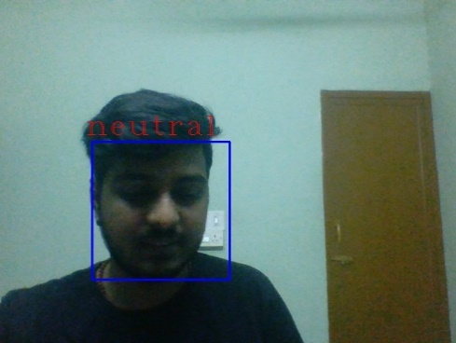

1. Neutral

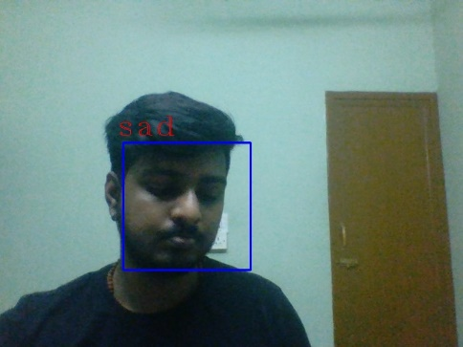

1. Sad

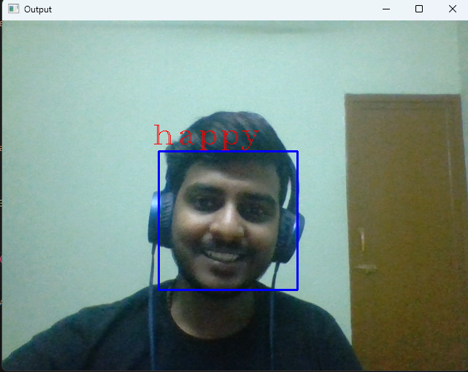

C) Happy

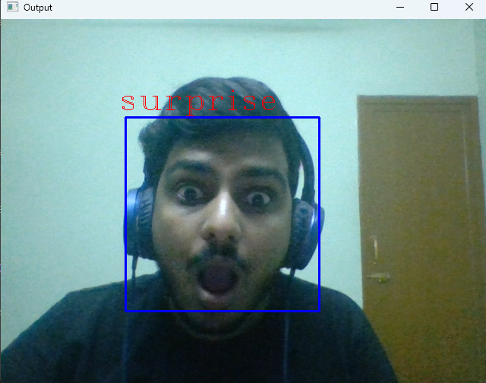

d)Surprise

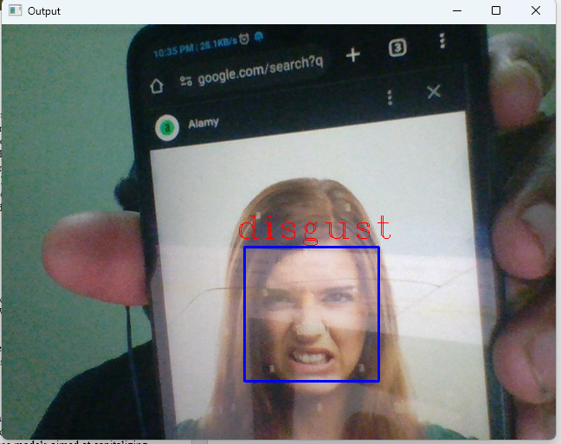

e) Disgust  
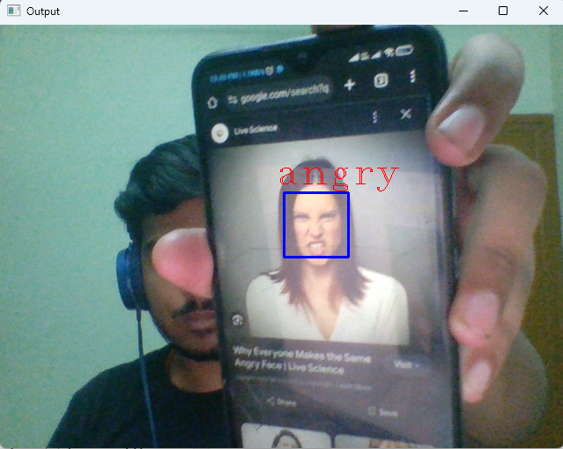

f) Angry

Conclusion:

Conclusion:

The comprehensive exploration into the realm of emotion detection through a fusion of image processing techniques and a diverse ensemble of machine learning models has yielded significant insights and advancements. By leveraging Convolutional Neural Networks (CNNs), Support Vector Machines (SVM), Random Forest, K-Nearest Neighbors (KNN), and Logistic Regression, we aimed to enhance the accuracy, robustness, and adaptability of facial emotion recognition.

Key Findings:

1.Model Performance:

The neural network model demonstrated commendable accuracy in facial emotion recognition, surpassing traditional machine learning models like SVM, Random Forest, KNN, and Logistic Regression.

Comparative analysis highlighted the strengths of deep learning in capturing intricate patterns and nuances within facial expressions.

2.Ensemble Learning:

Ensemble learning, incorporating SVM, Random Forest, KNN, and Logistic Regression, showcased varying degrees of success. The combination of these models aimed at capitalizing on their individual strengths for a more robust system.

3. Real-time Application:

The integration of the developed models into a real-time application using a webcam illustrated practicality and usability for applications in human-computer interaction and beyond.

Challenges and Opportunities:

1.Data Quality:

The accuracy and reliability of emotion detection heavily rely on the quality and diversity of the training dataset. Addressing imbalances and expanding the dataset could further enhance model performance.

2, Model Interpretability:

While deep learning models excel in accuracy, interpreting their decisions can be challenging. Efforts towards model interpretability and explainability could facilitate broader adoption.

3, Adaptability:

Emotion recognition systems should be adaptive to diverse demographics, cultural nuances, and individual differences. Future work could explore methods to enhance adaptability.

Future Directions:

1.Fine-tuning and Transfer Learning:

Continuous refinement of the neural network through fine-tuning and transfer learning strategies could lead to even higher accuracy, especially when faced with new datasets.

2.Integration with Multimodal Data:

Exploring the integration of additional modalities, such as audio and text, could contribute to a more holistic understanding of human emotion.

3.Human-Centric Applications:

Further research into applications that focus on human-centric scenarios, including mental health monitoring and personalized user experiences, could open up new avenues for emotion detection technology.

In conclusion, the project has laid a solid foundation for advancing facial emotion recognition. The amalgamation of image processing and machine learning models has not only showcased the current capabilities but has also outlined promising pathways for future exploration and innovation in this dynamic field.

**REFERENCES**

* [**https://www.kaggle.com/**](https://www.kaggle.com/)
* [**https://jupyter.org/**](https://jupyter.org/)
* [**https://ieeexplore.ieee.org/document/9214207**](https://ieeexplore.ieee.org/document/9214207)
* [**https://ieeexplore.ieee.org/document/9897786**](https://ieeexplore.ieee.org/document/9897786)
* [**https://ieeexplore.ieee.org/document/8806408**](https://ieeexplore.ieee.org/document/8806408)
* [**https://www.kaggle.com/datasets/narminj/fer2013-resnet-100-epochs/data**](https://www.kaggle.com/datasets/narminj/fer2013-resnet-100-epochs/data)
* [**https://www.tensorflow.org/tutorials**](https://www.tensorflow.org/tutorials)
* [**https://pytorch.org/tutorials/**](https://pytorch.org/tutorials/)
* [**https://keras.io/**](https://keras.io/)
* [**https://scikit-learn.org/stable/modules/svm.html**](https://scikit-learn.org/stable/modules/svm.html)
* [**https://www.csie.ntu.edu.tw/~cjlin/libsvm/**](https://www.csie.ntu.edu.tw/~cjlin/libsvm/)
* [**https://scikit-learn.org/stable/modules/neighbors.html**](https://scikit-learn.org/stable/modules/neighbors.html)
* [**http://yann.lecun.com/exdb/publis/pdf/lecun-01a.pdf**](http://yann.lecun.com/exdb/publis/pdf/lecun-01a.pdf)
* [**https://code.visualstudio.com/**](https://code.visualstudio.com/)
* [**https://machinelearningmastery.com/crash-course-convolutions-deep-learning/**](https://machinelearningmastery.com/crash-course-convolutions-deep-learning/)
* [**https://pytorch.org/tutorials/beginner/blitz/cifar10_tutorial.html**](https://pytorch.org/tutorials/beginner/blitz/cifar10_tutorial.html)